Contact

Project Guide
14-May-2020

Shrikant Barkul

Introduction
Project is created from Spring Initializr https://start.spring.io/ with Maven as build tool with spring boot , Java 8, and packging as jar.

Framework / tools used
1] Hibernate Validation
2] JUnit Jupiter
3] Spring Boot
4] Swagger (For docuentation)
5] H2 database. (We can change database as per our requirement).

To build and run this project system must have
1] Any IDE (Mostly STS / Eclipse)
2] Java 8
3] Maven
4] Connection to internet for downloading dependencies.

Steps to run this project

1] Import contact project from https://github.com/shrikantbarkul/evolent.git
2] Open Contact Project and clean project by using maven clean
Right click on project --> Run As --> Maven Clean
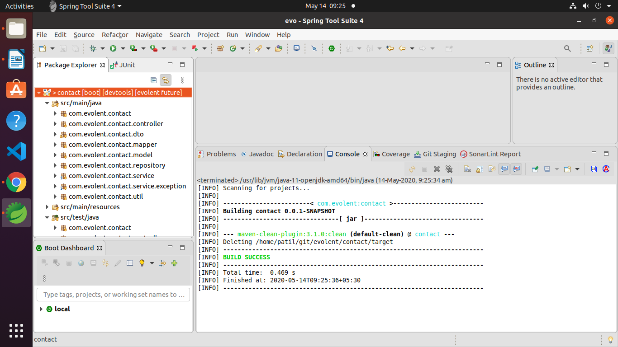
3] Build the project using maven
Right click on project --> Run As --> Maven Install
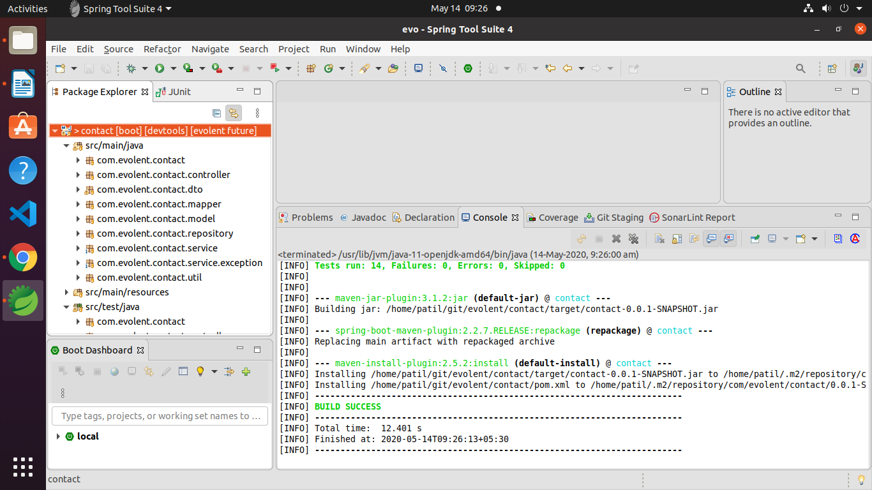
4] If you are having some build error, update the project and try to build again
Right click on project --> Maven --> update project
Right click on project --> Run As --> Maven Install
5] Now project will download some dependencies, let this finish
6] Start the application
Right click on project --> Run As --> Java Application / Spring boot app
7] Select the ContactAplication.java file for run if asked

Now project is ready to use.

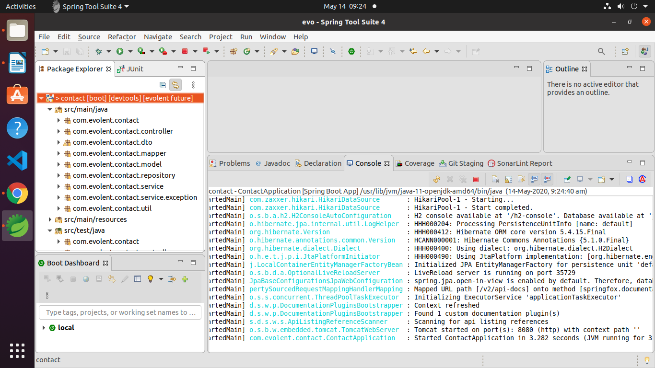

Testing the Project

Once project is started Go to browser and go to URL

http://localhost:8080/swagger-ui.html

This will open documentation for Service

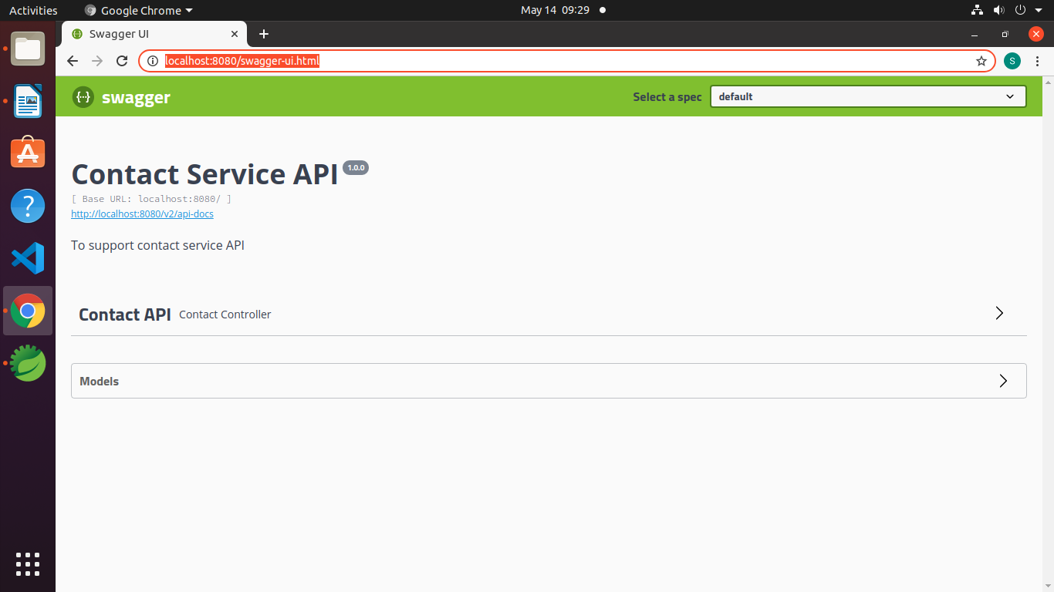
Click on contact API. It will display list of APIs available

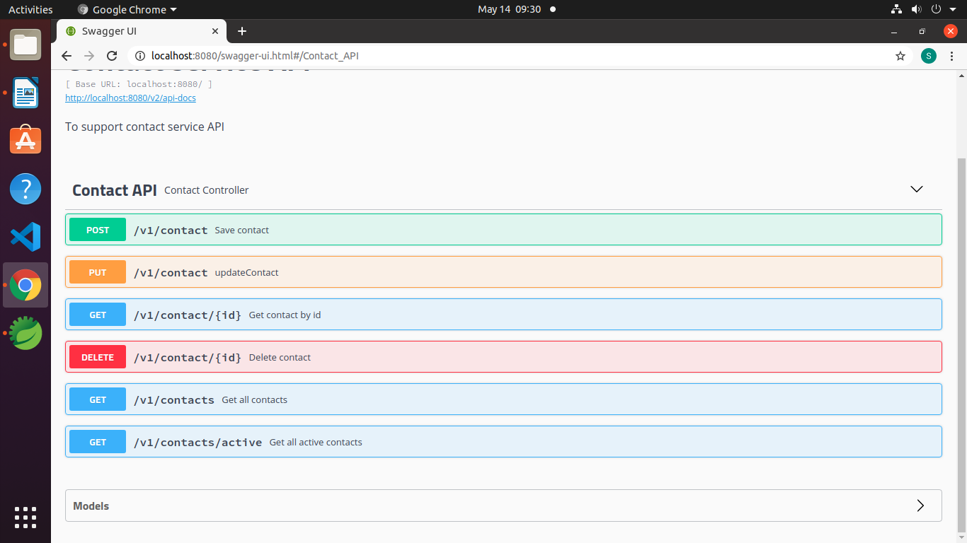

From here we can test our application

1] First we will save one contact
click on POST Save contact
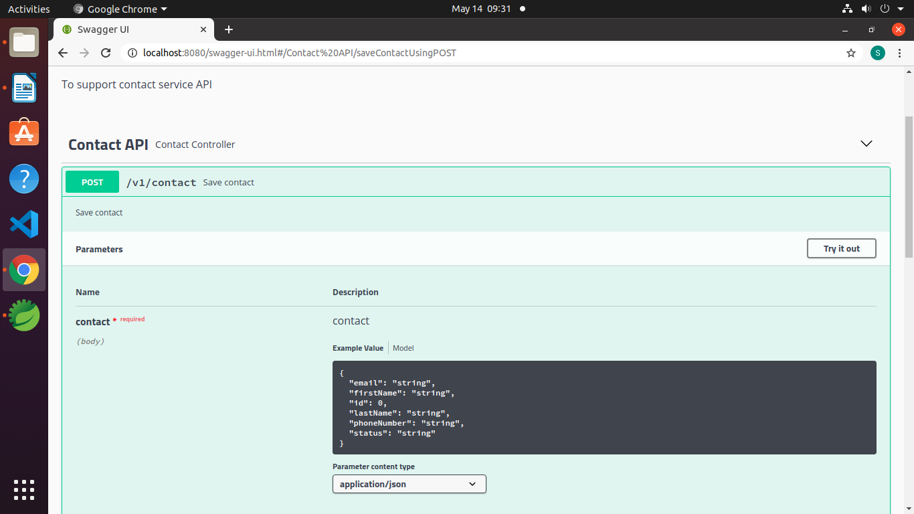

click on Try it out

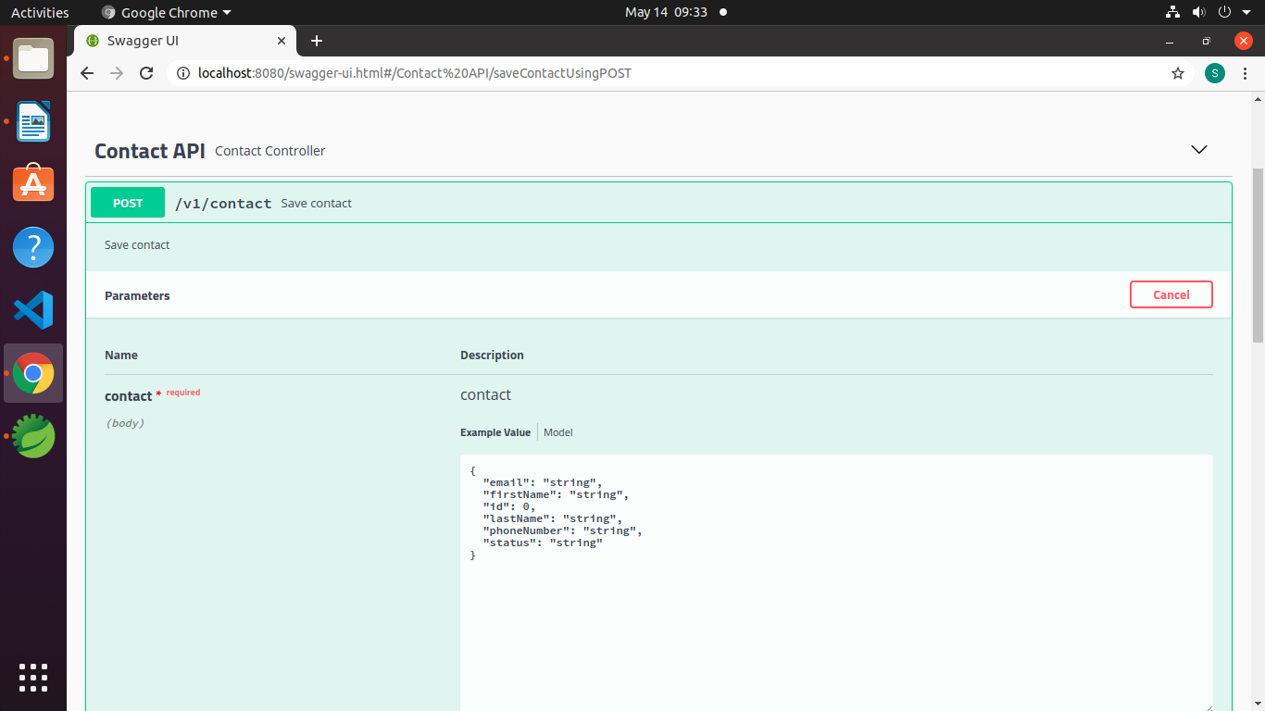

Change the payload you want to save for example

{
"email": "shrikantbarkul@email.com",
"firstName": "Shrikant",
"lastName": "Barkul",
"phoneNumber": "8600026600",
"status": "Active"
}

We have applied some validations so It may return status as exception if you are not giving correct values.
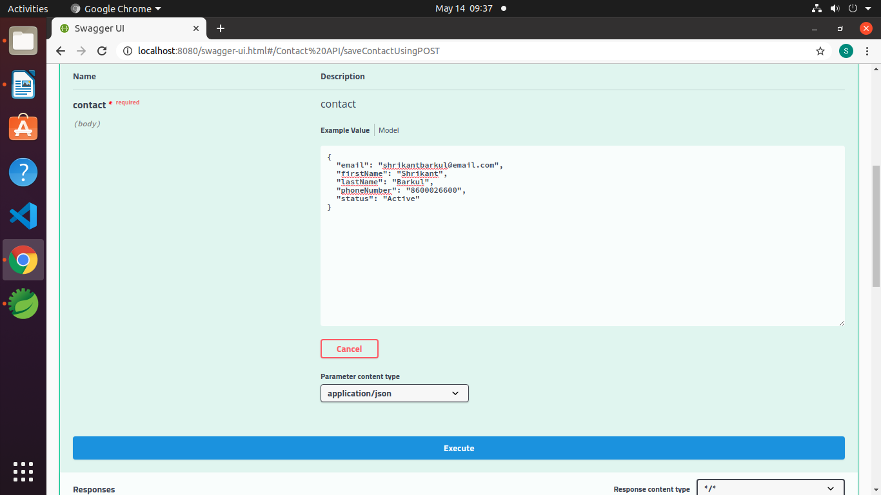
Click on execute

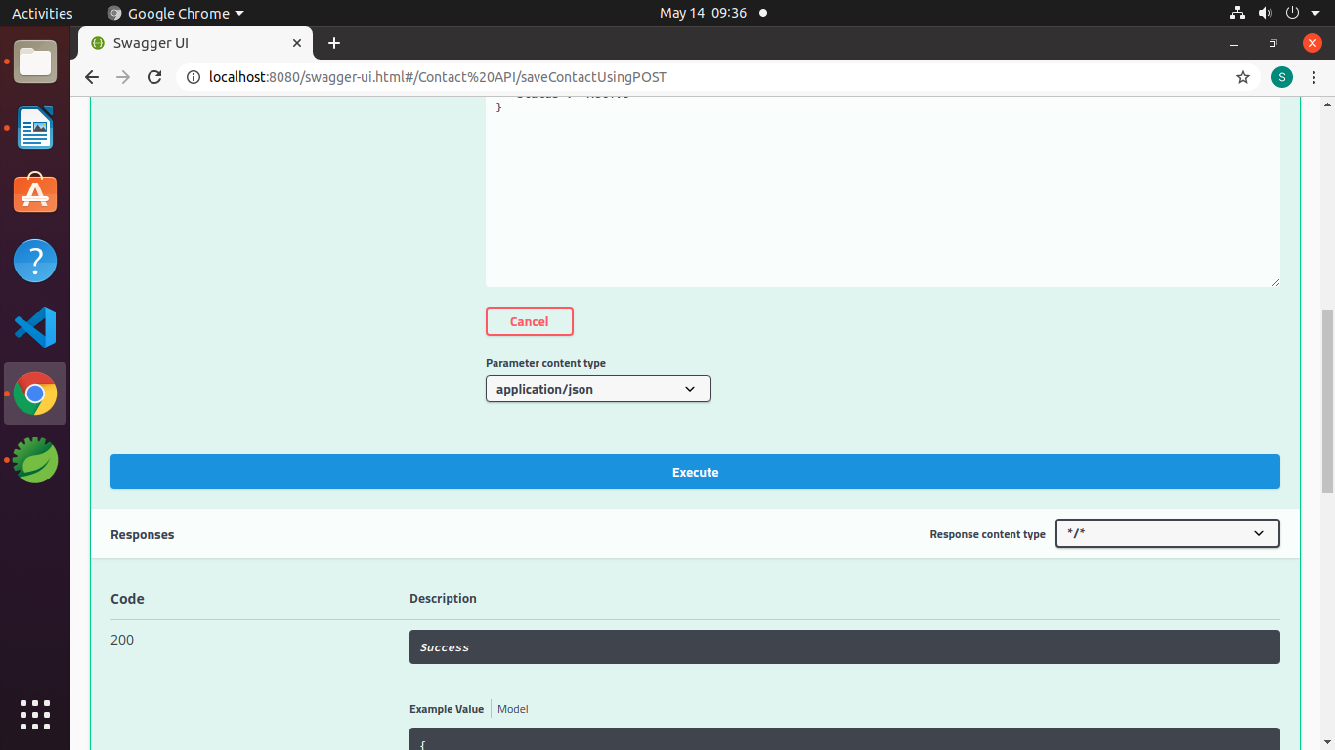

We will get id as response body

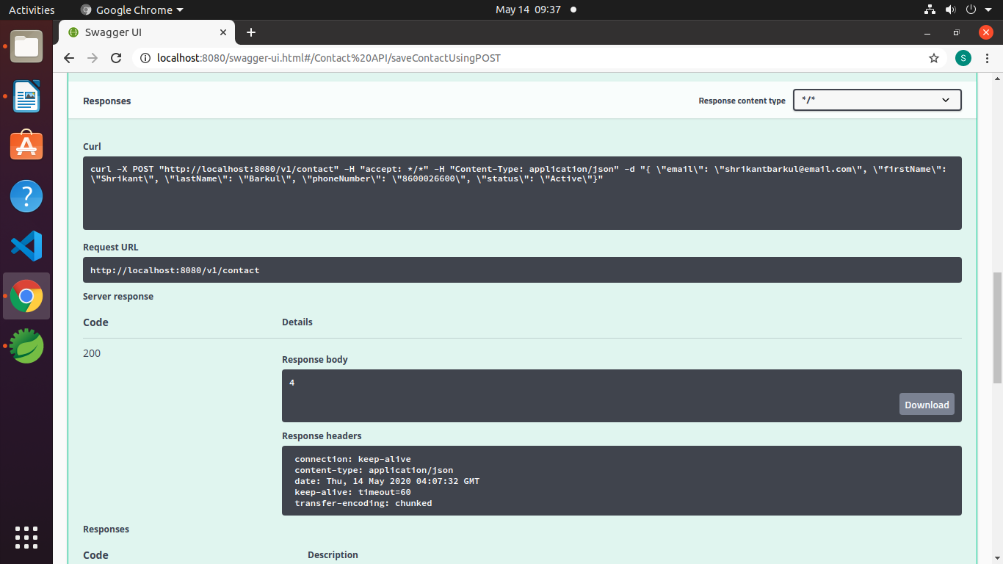

To check object is saved or not click on get contact --> try it out --> give id as your response

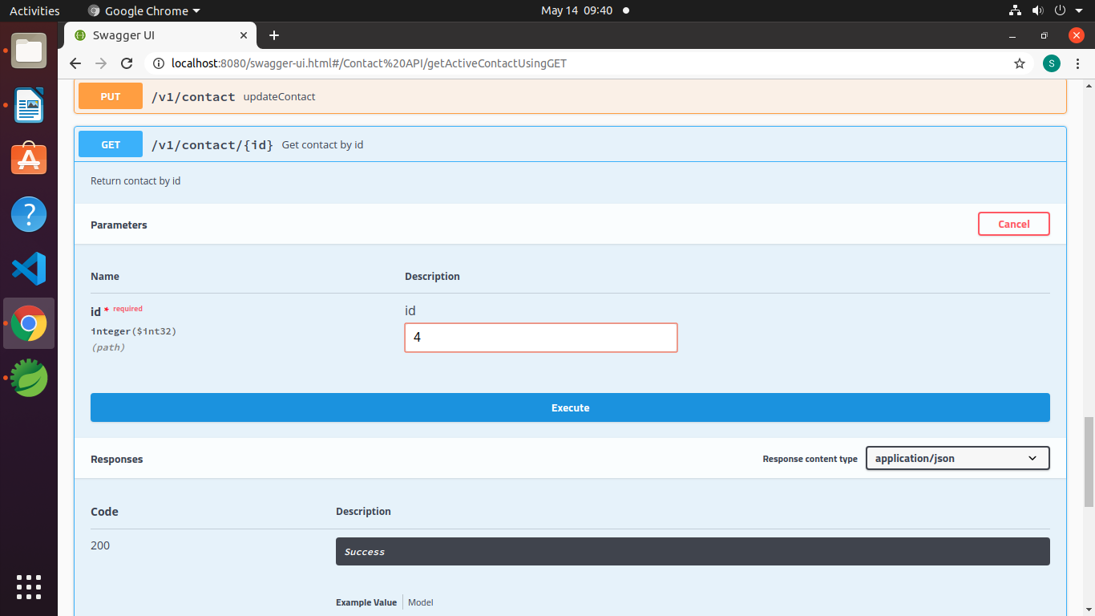
click on execute and see the response

In this way you can test other services also.

Thank You
Shrikant Barkul
+91 86000 26600

